Naveen Kumar. T-JUnit, Mockito and SL4J
1) JUnit Testing Exercises
Exercise 1: Setting Up Junit
Output:
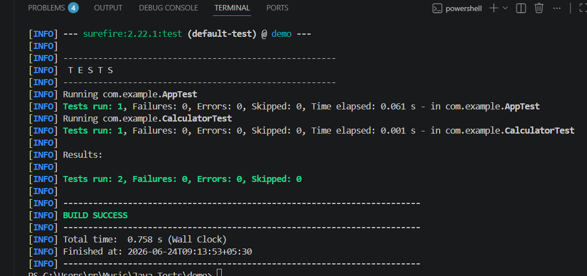

Exercise 2: Writing Basic JUnit Tests
Output:
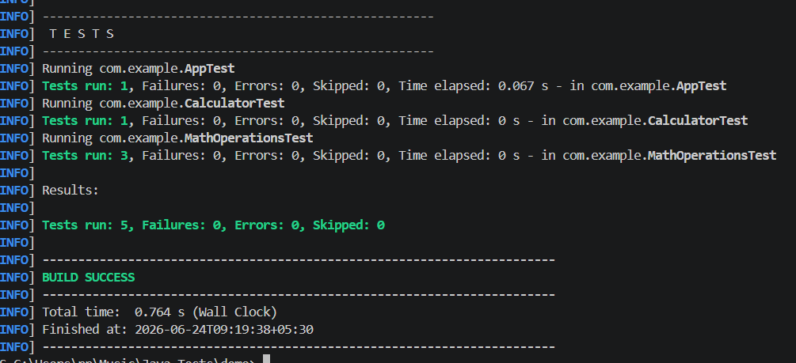

Exercise 3: Assertions in Junit
Output:
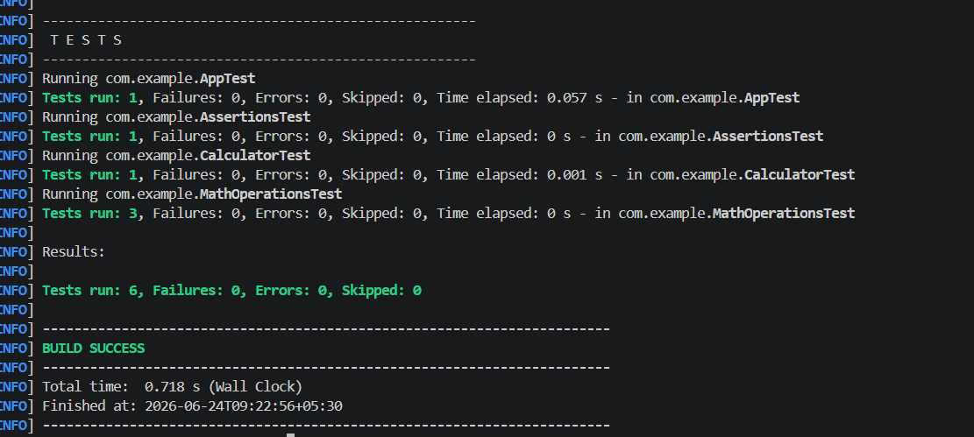

Exercise 4: Arrange-Act-Assert (AAA) Pattern, Test Fixtures, Setup and Teardown Methods in Junit
Output:
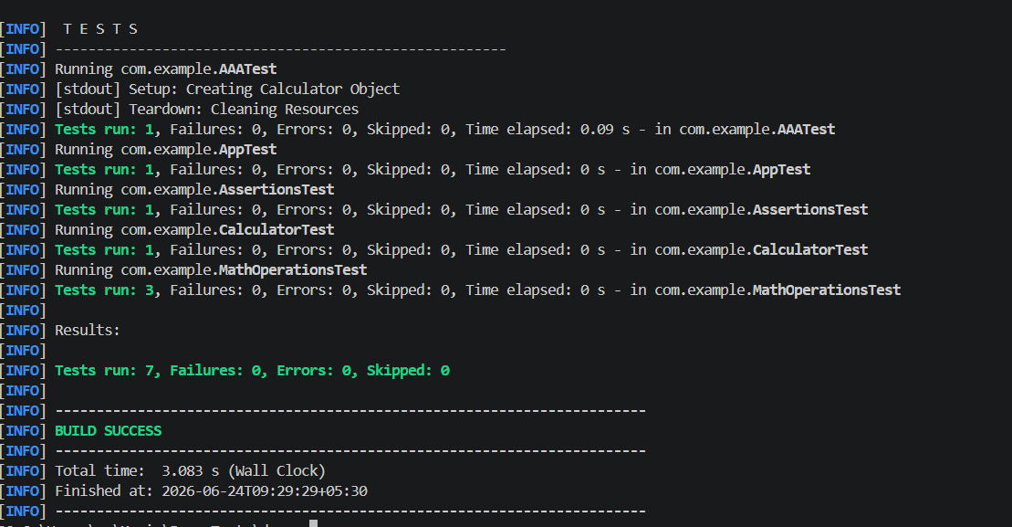
2) Advanced JUnit Testing Exercises
Exercise 1: Exercise 1: Parameterized Tests
Output:
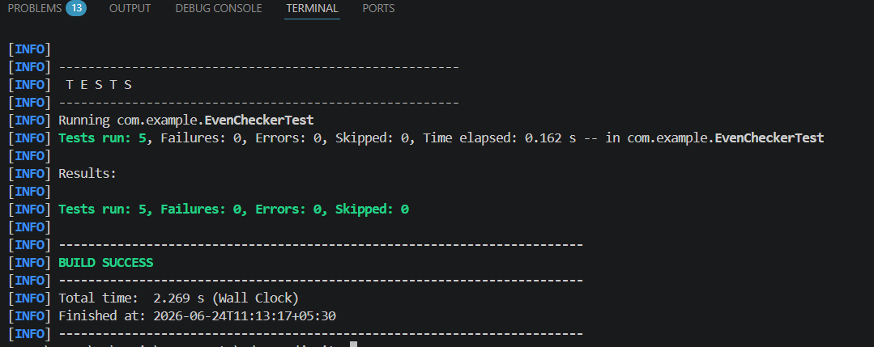

Exercise 2: Exercise 2: Test Suites and Categories
Output:
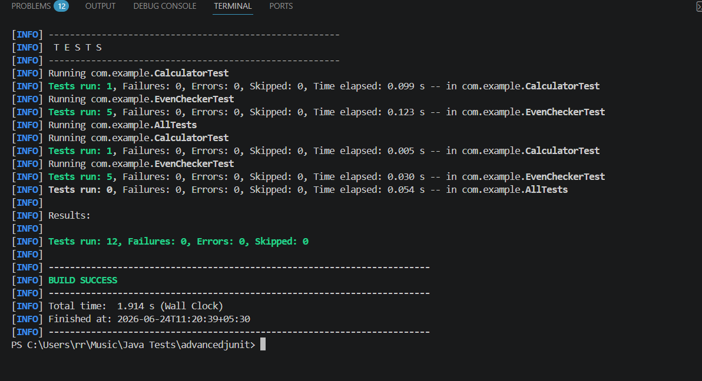

Exercise 3: Exercise 3: Test Execution Order
Output:
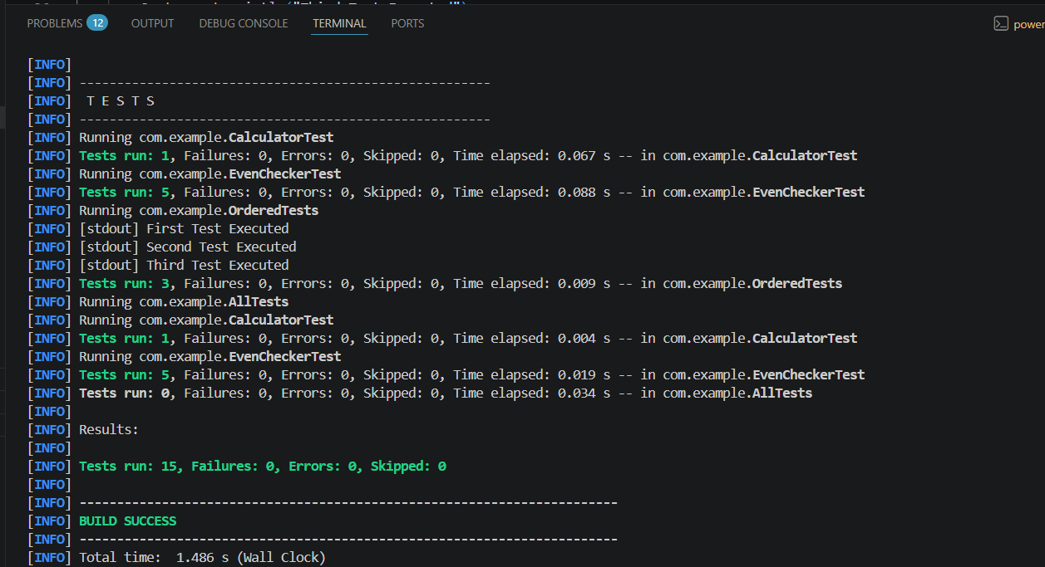

Exercise 4: Exception Testing
Output:
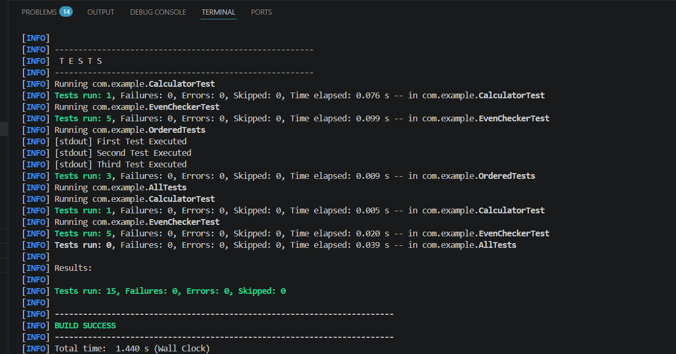

Exercise 5: Timeout and Performance Testing
Output:
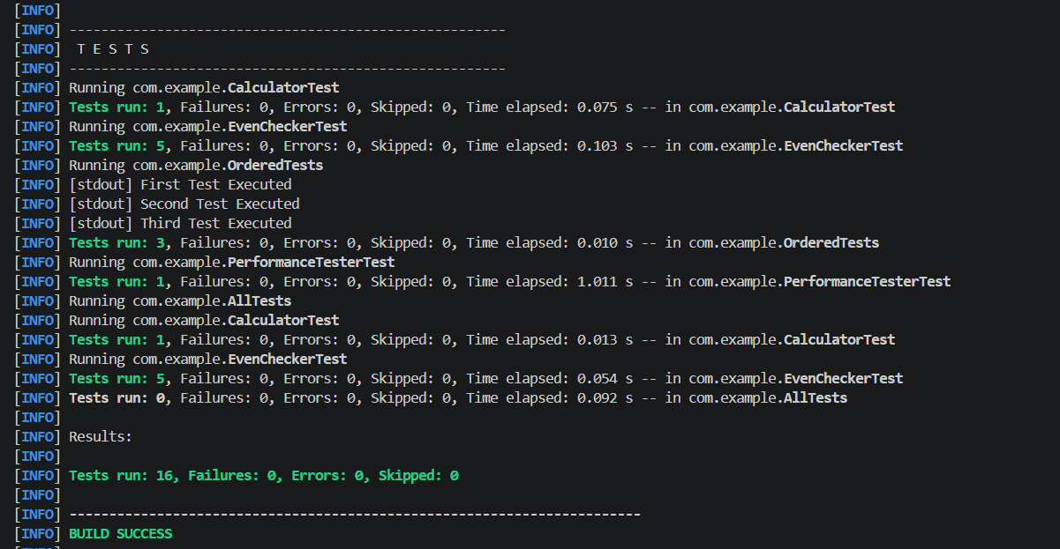

3)Mockito Hands-On Exercises
Exercise 1: Mocking and Stubbing
Output:
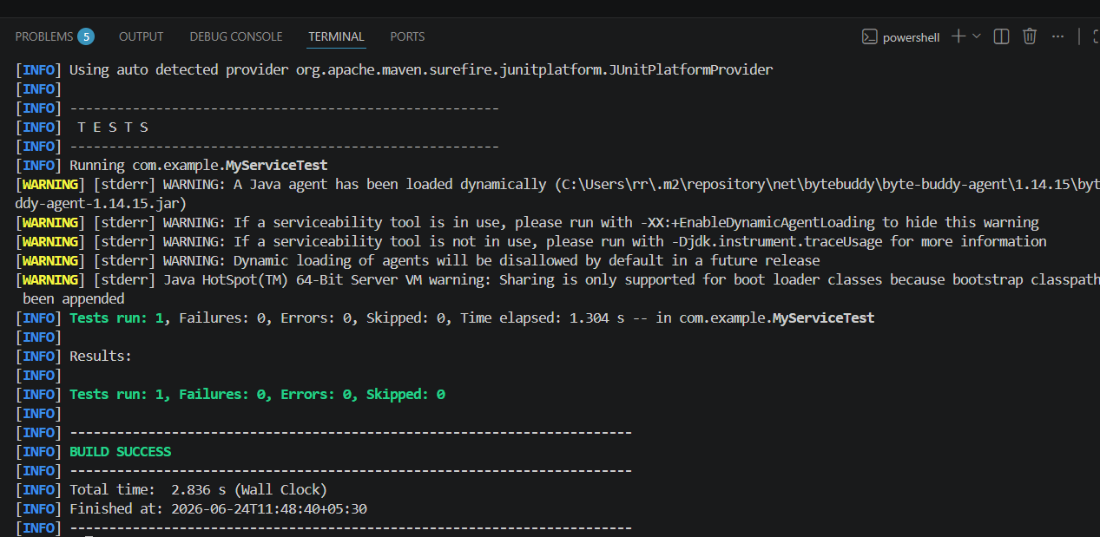
Exercise 2: Verifying Interactions
Output:
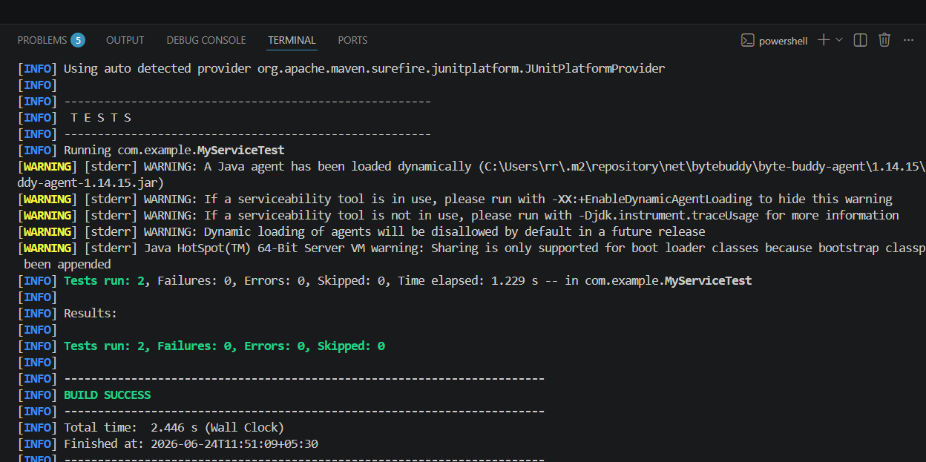
Exercise 3: Argument Matching
Output:
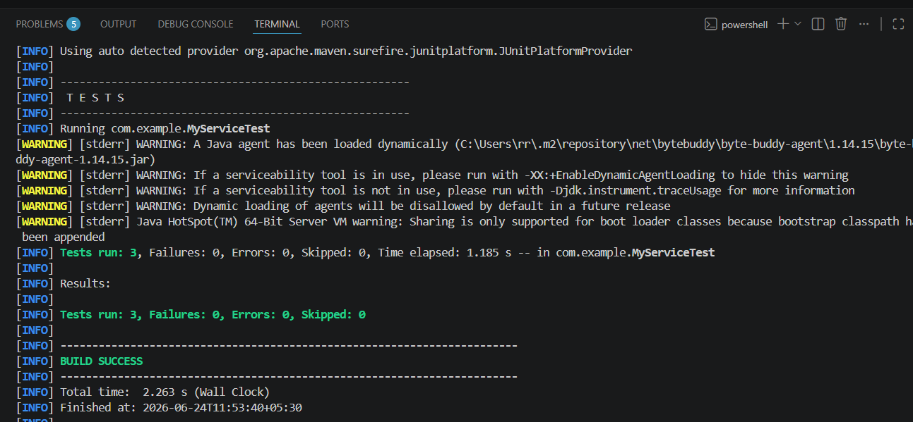

Exercise 4: Handling Void Methods
Output:
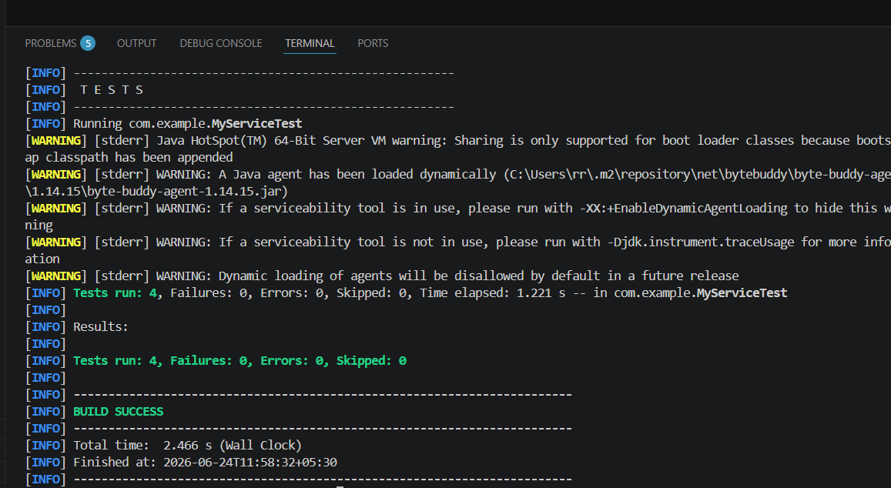

Exercise 5: Mocking and Stubbing with Multiple Returns
Output:
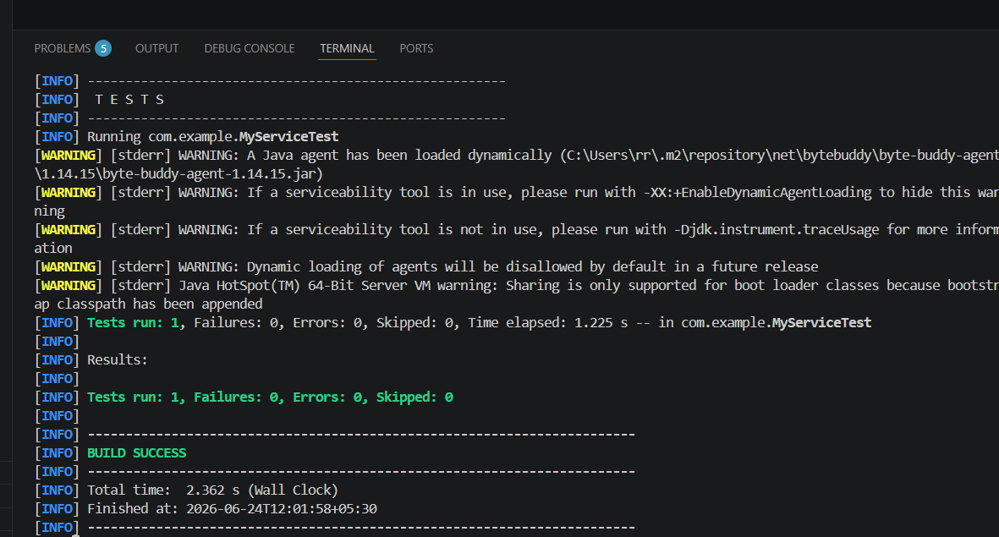

Exercise 6: Verifying Interaction Order
Output:
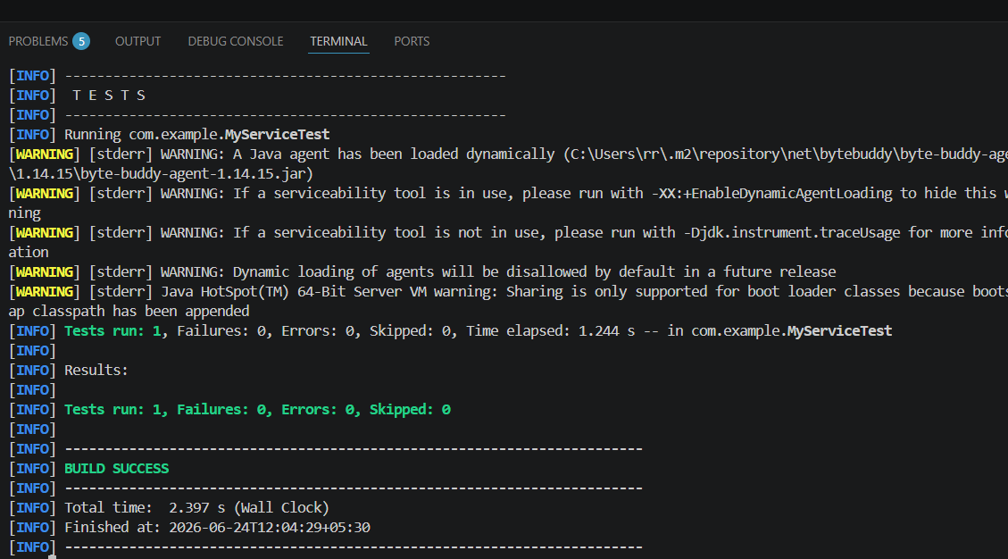

Exercise 7: Handling Void Methods with Exceptions
Output:
